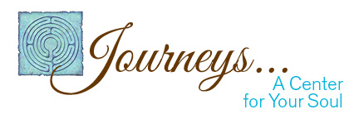
Journeys…A Center for Your Soul
Vanessa Underwood, PMHNP
1595 Cottage St. N.E.
Salem, OR 97301

Acknowledgment and Notice of Privacy Consent

By signing below, I hereby acknowledge receipt of Journeys…A Center for Your Soul/Vanessa Underwood, PMHNP Notice of Privacy Practices.

Signature of Patient (or Personal Representative) Date of Signature

Patient Name

FOR OFFICE USE ONLY

We attempted to obtain written Acknowledgment of receipt of our Notice of Privacy Practices, but acknowledgment could not be obtained because:

Individual refused to sign

Communication barriers prohibited obtaining the acknowledgment

An emergency situation prevented us from obtaining acknowledgment

Other (please specify)_____________________________________________

